**I WANT TO INVITE CORPORATE SPONSORS**

[Do you or someone you know work for a company that makes treats or snacks? Does your Mid particularly love a regional item and you are comfortable asking them to send some to the Academy?](http://www.kpcookiecafe.com/schedule.html)

[**Here are the Step-by-Step directions on how to ask for a Corporate Sponsorship:**](http://www.kpcookiecafe.com/schedule.html)

[1. The following is a letter that I sent out when I did a “Tour of Pennsylvania” Cookie Cafe and got all sorts of goodies!! Adapt that letter any way that you like or write your own. I will also send you a document explaining exactly What Is Cookie Cafe. Feel free to print it off and send it with your letter.](http://www.kpcookiecafe.com/schedule.html)

[2. If you get a company that says YES, please send me an](http://www.kpcookiecafe.com/schedule.html) [email](mailto:hartlesly@yahoo.com) [or PM. Sometimes, if they have a New York branch, they prefer to just deliver straight to the Academy and I need to coordinate that effort. Sometimes they will need to ship. Sometimes they will want YOU to ship. Just let me know.](http://www.kpcookiecafe.com/schedule.html)

[3. After the date of the Cafe, please come back to the](http://www.kpcookiecafe.com/schedule.html) [Cookie Cafe photos](https://www.kpcookiecafe.com/photos.html) [and/](http://www.kpcookiecafe.com/schedule.html)

[or the KP Cookie Cafe FB page and check out the pictures!!!!](http://www.kpcookiecafe.com/schedule.html)

[4. Please send a personal Thank You to the company letting them know how much we appreciate their donation. Please include our website address,](http://www.kpcookiecafe.com/schedule.html) [kpcookiecafe.com](http://www.kpcookiecafe.com/)[, so that they can go online and check out the pictures. There will be a Thank You sign on their donation and pictures will, most likely, be taken. If they need some sort of documentation of their donation (we are a 501(c)(3) organization) let me know and we’ll make that happen.](http://www.kpcookiecafe.com/schedule.html)

[Please, please know that we work VERY HARD to keep this a well-oiled machine and](http://www.kpcookiecafe.com/schedule.html)

[keep everything on track. That being said, things do happen for unforeseen reasons. If](http://www.kpcookiecafe.com/schedule.html) something does happen, please send me an [email](mailto:hartlesly@yahoo.com) or PM me and we’ll see what we can do to make it right.

PS. Here are the donations I got when I did a Tour of Pennsylvania (I was driving up so I just took everything):

1. 15 gallons of chocolate milk from a local dairy

2. 6 cases of ice tea drinks from Turkey Hill Mini Market

3. A full sheet cake from a local grocery store

4. 10 cases of chips, pretzels, snacks from Herr’s Chips

5. A full table of chocolate candies from a local candy store

6. 5 cases of yogurts from a different local grocery store

Thank you and have fun with it!

Leslie Hart, Sponsor Coordinator

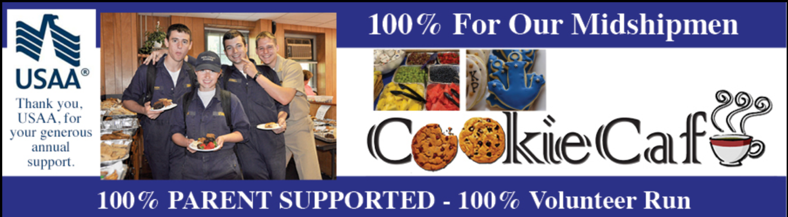

[www.kpcookiecafe.com](https://www.kpcookiecafe.com/index.html) [Paypal Donations](https://www.paypal.com/donate/?cmd=_s-xclick&hosted_button_id=Q39C57W9CY7LY&ssrt=1719953532536)

**Kindly donate to over 1000 future Commissioned Officers   
in the US Military and Merchant Marine. Here’s how:**

Dear ____________________,

I am the proud parent of a Midshipman at the United States Merchant Marine Academy, a Federal Service Academy located in Kings Point, New York. Since 2007, parents at USMMA have worked together to sponsor **Cookie Café** events on campus. This means an occasional Thursday afternoon banquet offering of delicious *home-baked* goodies, fresh fruit, cheeses, snacks and a full compliment of beverages. *This all free of charge to the Midshipmen!* And the students love, love, love those days. Parents bake treats and ship hundreds of boxes from all across the country. The Academy is hugely supportive and allows us to use the student center as a venue. In this next ’24-‘25 academic year, there are 15 Cookie Café events scheduled from September ’24 through May ‘25.

Cookie Café Corporation is a 501(c)(3) non-profit, and is 100% supported by the students’ parents and families, alumni and even the local Girl Scout Troop. I am hoping that you would like to be a part of the truly-best day of the week for our hard-working and very dedicated Midshipmen with a donation of your choice, be it monetary or consumable!

During each event, volunteers take pictures of the Midshipmen enjoying your generosity. These photos are put into an album and posted on our [FaceBook Group](https://www.facebook.com/groups/118766484940602/media/albums) which is private to protect the students, so please request access and we’ll be delighted to invite you. In addition, as a contributor, we will add your company name and website link to our [website schedule](https://www.kpcookiecafe.com/schedule.html). This information will remain live for the current academic year. It just might be a wonderful addition to a corporate profile or financial report. 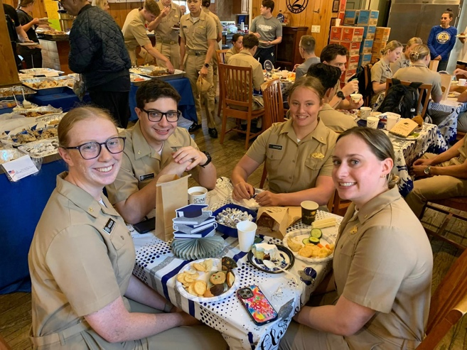

Upon graduation, these Midshipmen are commissioned as officers in the US Military branch of their choice. They also earn a four-year bachelor’s degree and a United States Coast Guard license in their field of engineering or navigation. During those four years, they have sailed as navigators or systems engineers on commercial or Navy ships for a total of 12 months. This takes them most anywhere in the world, and on many different ships. They go on to serve their country for at least 6 years as payback for their extraordinary education.

So this little bit of “home,” Cookie Café, is a welcoming and appreciative treat for our shining examples of young men and women who will serve our country for many years.

All of us at Cookie Café, a place that has dished out literally millions of treats and beverages over the years, wish you will help as we continue to sail forward and honor the Midshipmen of the US Merchant Marine Academy. Please contact me any time to join in, and thank you in advance for your consideration!

(Your Name & Contact info)